Gidi Rush – How to Use
A 3D Temple Run-style endless runner through the streets of Lagos.

What it does
Run through Lagos, dodge danfos, kekes and okadas, jump gutters and potholes, slide under owambe banners, turn at junctions and collect naira before the agbero catches you. Works offline – no install, account or internet needed.
- Three runners: Tunde the Student, Amaka the Market Queen, Chidi the Footballer.
- Areas: Lagos Island Market, Lekki (with the toll gate), Third Mainland Bridge.
- Power-ups: Magnet, Shield, Double Kudi, Okada Boost.
- Original Afrobeats-style music and Pidgin lines.

How to open it on Windows

Option 1 (simplest)
Double-click index.html in the lagos-rush folder.

Option 2
Double-click start.bat. It starts a small server at http://localhost:8080 (next free port if busy) and opens your browser. Without Node.js it opens index.html instead.

Logins
None needed.

Controls
Action | Keyboard | Touch / mouse
Change lane | Left / Right arrows (or A / D) | Swipe left / right
Turn at a junction | Left / Right arrows at the corner | Swipe left / right
Jump | Up arrow, W or Space | Swipe up
Slide | Down arrow or S | Swipe down
Pause | P or Esc | Pause button
Mute | M | Speaker button
Start / restart | Enter | Tap the button

How to play
1. Pick your runner and press start.
2. You run forward automatically and get faster.
3. At junctions (yellow chevrons, toll gate, Balogun front, "Road closed") turn in the arrow direction before the wall – or the run ends.
4. Jump potholes, gutters, generators and barriers; slide under banners and low bridges; change lanes to dodge vehicles and stalls.
5. Each stumble lets the agbero close in. Stumble again within about 7 seconds and he catches you.
6. Each naira coin is 10 points (20 with Double Kudi).
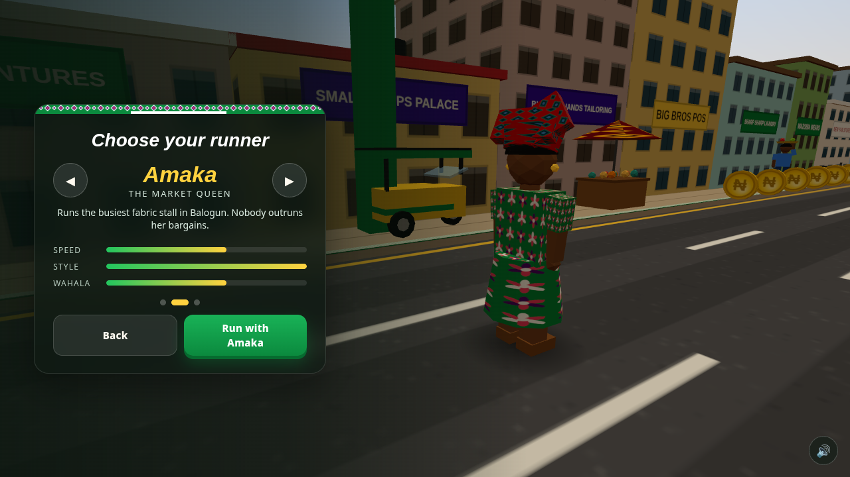
Choose your runner
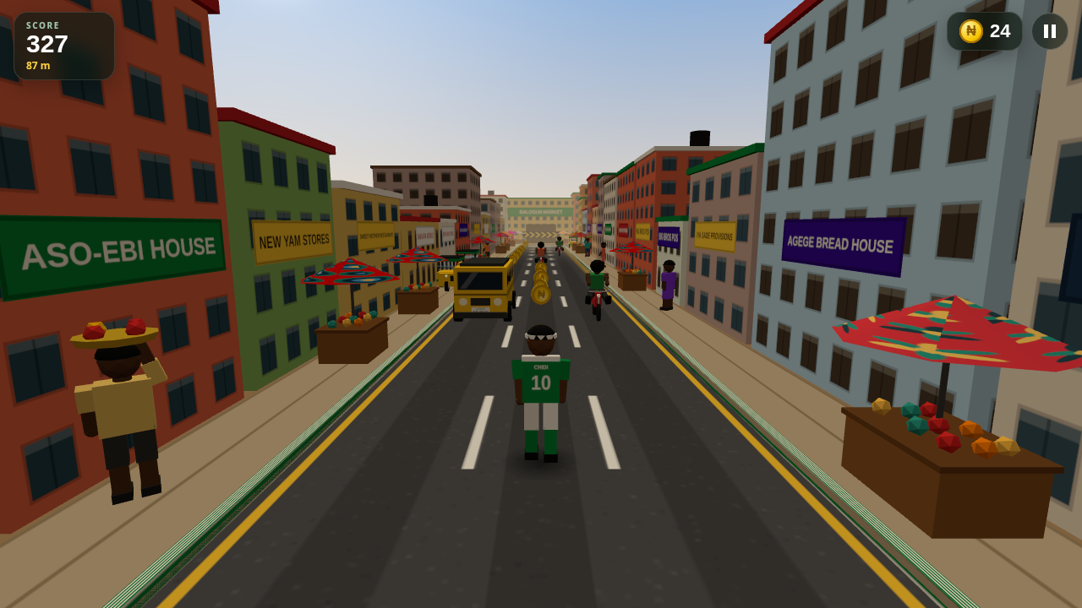
Dodging danfo traffic
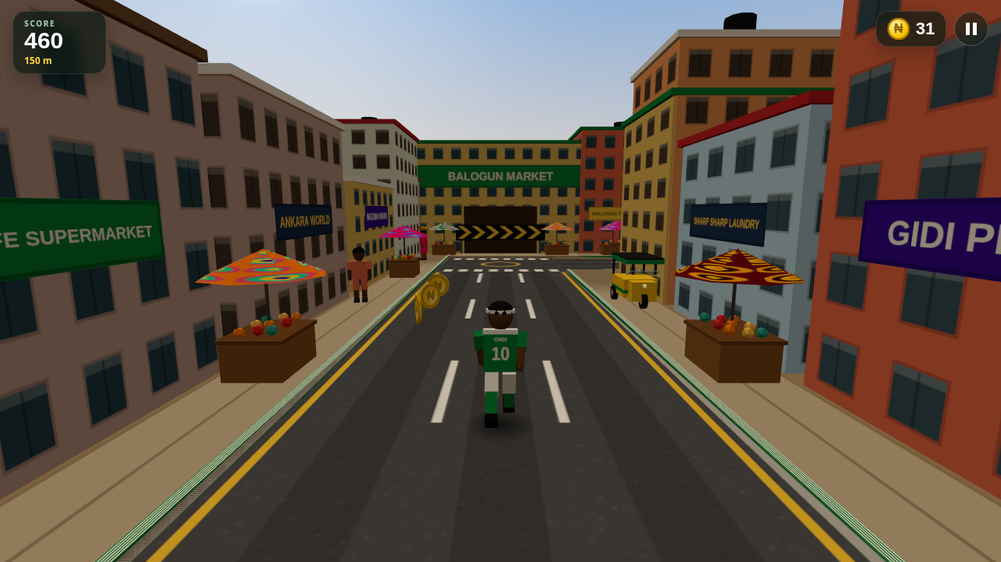
Turn at the junction
Power-up | Effect
Magnet | Nearby naira flies to you for 10 s
Shield | Absorbs one crash or missed turn (12 s)
Double Kudi | Doubles your score for 10 s
Okada Boost | Ride an okada for 5 s: faster, smashes obstacles, auto-turns

Saved progress and reset
Best score, naira banked, runs, chosen runner and settings are saved in your browser. Clearing the browser's site data resets them.

Troubleshooting
Problem | What to do
The game is slow / choppy | Settings → Graphics → Low. Turn on "Show FPS" to check.
No sound | Press M to unmute, and click once on the page (browsers need a click before sound).
start.bat opened index.html | Node.js not found – that is fine, the game works either way.
Port 8080 busy | Close the other program, or just use index.html.

Honest limitations
- Single-player, offline game; scores are only stored on this device.
- Graphics are simple low-poly models made in code.
- Tip: add ?seed=123 to the address to replay the same city layout.

